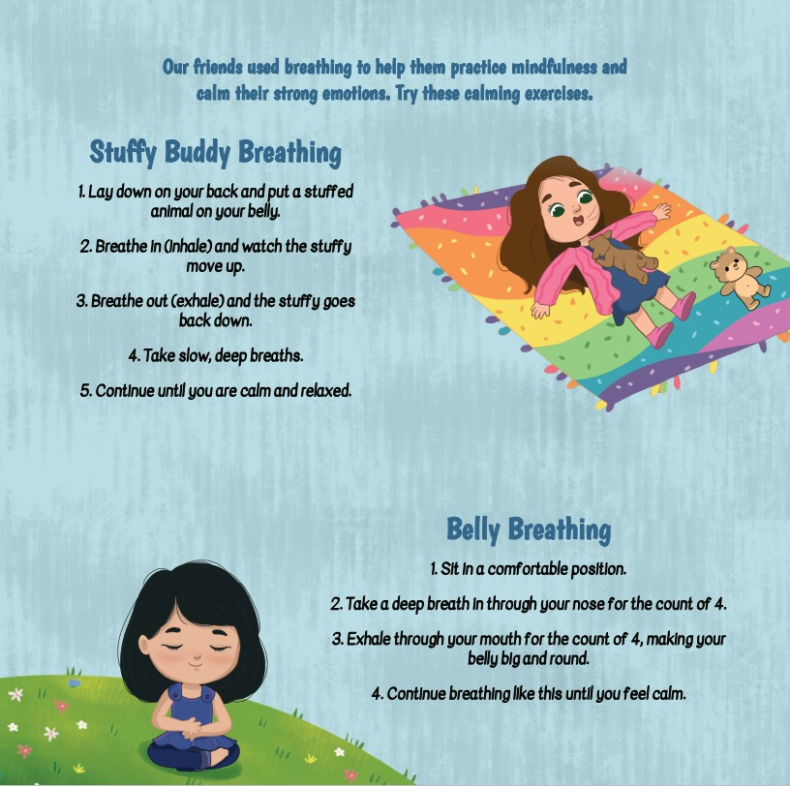
Copyright Kindness & Stories – for classroom use only
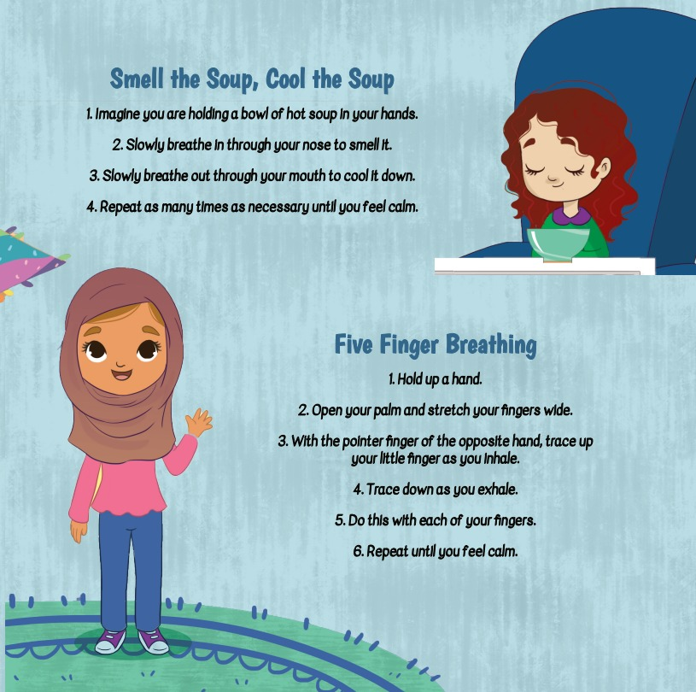
Copyright Kindness & Stories – for classroom use only
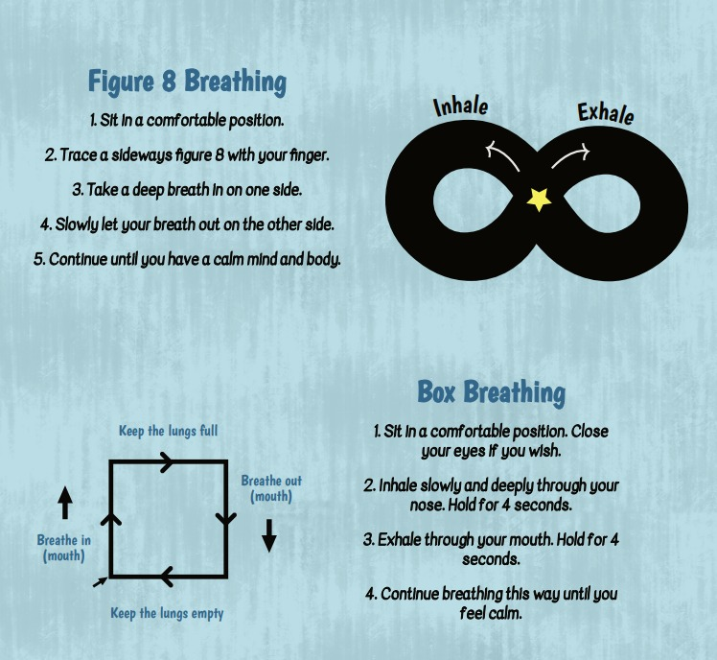
Copyright Kindness & Stories – for classroom use only

